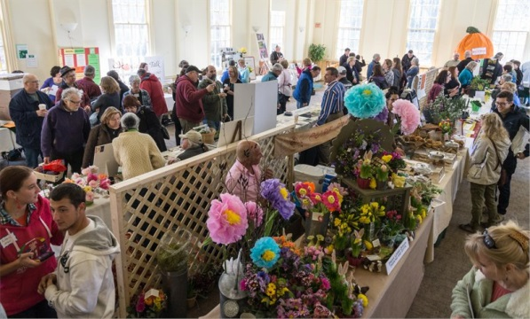
The Topsfield Garden Club invites you to participate in our Seventh annual Grow Spring! Expo to be held on Saturday, April 4, 2020 from 10:00 am - 3:00 pm at Proctor School, located on the Topsfield Town Common. This popular and growing event celebrates local agriculture, horticulture, and environmental preservation, and connects organizations like yours with each other and the wider community. We hope that you will join us and enjoy the camaraderie of a day among grow local enthusiasts!

We are very excited about our new location at Proctor School. Last year over seventy exhibitors and vendors were distributed among four crowded venues. Proctor School will allow for all to be together under one roof with ample space. One area will be set up as a Farmer’s Market with seating for visitors enjoying a snack or lunch from the Farmer’s Market or vendors located outside. The Main Hall will accommodate the majority of exhibitors and vendors with overflow into spacious and inviting hallways.

Participants are encouraged to bring locally-grown produce and farm products, garden tools, containers, seeds, bulbs, plants, books, crafts, field guides, etc. to sell. A small vendor fee of $15.00 will be charged only to participants who wish to sell items. There is no charge for exhibitors who would like to display information about their organization, farm or agricultural related business, or to non-profit groups selling merchandise. Exhibiting at the Expo is a great opportunity to reach out to the local community and offers a chance to meet other gardening and agricultural enthusiasts.

Once again there will be a scavenger hunt for kids, always a great hit! Several antique tractor, vintage trucks and farm equipment enthusiasts have agreed to return in force with a display of farm machinery.

In the interest of including as much garden and agricultural diversity as we possibly can in the confines of a 50 mile radius, please share this with friends, family, and acquaintances!
And, don’t hesitate to contact us with a link to someone you think would love to be involved.

Reservations will be taken on a first-come, first-served basis. There will be a substantial amount of promotion around this event, and if you respond by February 25th you will be included in our promotional material.

If you would like to participate, you can sign up online HERE or please complete the form below and send it to growspringexpo@gmail.com or The Topsfield Garden Club, PO Box 436, Topsfield, MA 01983,
as soon as possible so we can reserve your space!
Sponsors
Topsfield Garden Club – Proctor School - Topsfield Historical Society

Grow Spring! Expo
Please click here for a Word version of this form that you can complete on your computer, save and e-mail to us or mail to the address below

Vendor and Exhibitor Form
(Please note: This form is not required if you have already filled out the form on-line)

Company or Organization Name
Contact Name
Address
Telephone
e-mail
Special Requirements: We will try to accommodate your display needs such as wall space and electric outlets. Refrigeration is also available. Please let us know of any special needs you may have for your exhibit.

For Vendors wishing to sell products
Tax ID #
A brief description of the Item(s) you would like to sell:

Please note: Vendors selling Meats, Dairy Products, and Baked Goods must provide a Health Certificate with this form

The Topsfield Garden Club, PO Box 436, Topsfield, MA 01983

